Hands-on in this document

1. Create the project using npx create-react-app studentapp
2. Next open the folder in the vscode.
3. In the src folder, create components folder and create the following files in it –
Home.js
function Home() {
return (
<h2>Welcome to the Home page of Student Management Portal</h2>
);
}
export default Home;

About.js
function About() {
return (
<h2>Welcome to the About page of the Student Management Portal</h2>
);
}
export default About;

Contact.js
function Contact() {
return (
<h2>Welcome to the Contact page of the Student Management Portal</h2>
);
}
export default Contact;

4. Now modify the App.js file
import Home from "./Components/Home";
import About from "./Components/About";
import Contact from "./Components/Contact";
function App() {
return (
<div
style={{
display: "flex",
flexDirection: "column",
alignItems: "center", // Centers horizontally
textAlign: "center",
marginTop: "50px", // Moves content down from the top
}}
<Home />
<About />
<Contact />
</div>
);
}
export default App;
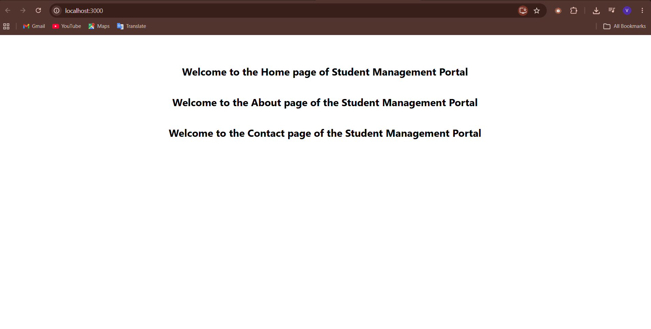

Objectives
1. Explain React Components
A React component is a reusable piece of code that creates a part of the user interface (UI). Components help organize code and make it easier to maintain.
Example: A Login form, Navbar, or Footer can each be a separate component.

2. Difference Between Components and JavaScript Functions
React Component | JavaScript Function
Used to create UI elements. | Used to perform a specific task or calculation.
Returns JSX (HTML-like code). | Returns data or a value.
Can use React features like state and props. | Cannot use React features directly.

3. Types of Components
There are two types of React components:
- Function Component
- Class Component

4. Explain Class Component
A Class Component is created using an ES6 class that extends React.Component. It can use state, props, and lifecycle methods.
Example:
class Welcome extends React.Component {
render() {
return <h1>Hello!</h1>;
}}
5. Explain Function Component
A Function Component is a simple JavaScript function that returns JSX. It is easier to write and is the most commonly used type of component in modern React.
Example:
function Welcome()
{
return <h1>Hello!</h1>;
}

6. Define Component Constructor
A constructor is a special method used in a class component. It is called when the component is created and is mainly used to initialize the component's state.
Example:
constructor(props) {
super(props);
this.state = { count: 0 };
}

7. Define render() Function
The render() function is used in a class component to display the UI. It returns the JSX that should appear on the screen.
Example:
render() {
return <h1>Welcome to React</h1>;
}
Function components do not use render(); they directly return JSX.

